**OOP2 Project**

**John Lyons (t00158576)**

**December 2014**

1. **GAME**

The game I’ve created is called Dirty Harry Simulator. It’s a text based shooting game where the player fights the A.I.

The game asks the user for their name, and then asks them to select a difficulty: easy, medium or hard. The player is then assigned a health number and an ammo count based on the difficulty selection via a random number generator.

The game then begins, and once it finishes you will be given the option to save your stats.

***Screenshots . . .***

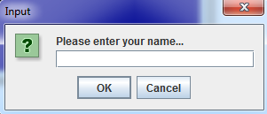

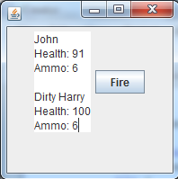

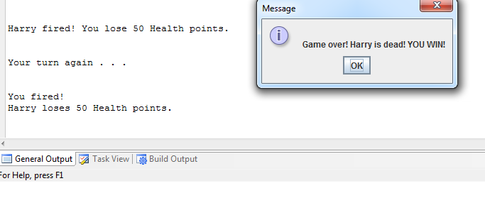

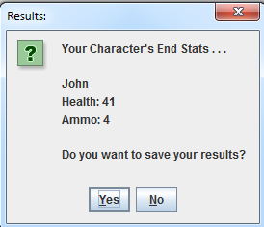

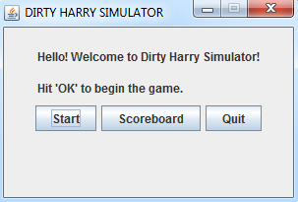

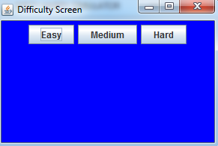

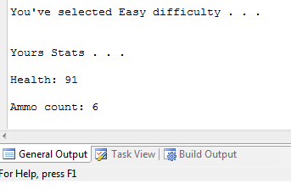

1. **CLASS DIAGRAMS**

|  |
| --- |
| GameLauncher |
| **+ mm: MainMenu** |
| **+ Main(args[]:String): void** |

|  |
| --- |
| MainMenu |
| **+ startButton: JButton**  **+ scoreboardButton: JButton**  **+ quitButton: JButton**  **+ jtf: JTextField**  **+ jl: JLabel** |
| **+ Main(args[]:String): void**  **+ MainMenu(): void**  **+ actionPerformed(e:ActionEvent): void**  **+ g: Game** |

|  |
| --- |
| DifficultyScreen2 |
| **+ easyButton: JButton**  **+ mediumButton: JButton**  **+ hardButton: JButton**  **+ jtf:JTextField**  **+ jl: JLabel** |
| **+ Main(args[]:String): void**  **+ DifficultyScreen2(): void**  **+ gameSetup(String difficulty, int healthChance, int ammoChance, int healthBase, int ammoBase): void**  **+ actionPerformed(e:ActionEvent):void**  **+ setHealth(int): void**  **+ setAmmo(int): void**  **+ getHealth(): int**  **+ getAmmo(): int**  **+ toString(): String** |

|  |
| --- |
| Game |
| **+ shootButton: JButton**  **+ area: JTextArea**  **+ frame: JFrame**  **+ p: Player**  **+ h: Harry**  **+ ds2: DifficultyScreen2** |
| **+ Game(DifficultyScreen2 diff): void**  **+ save():void**  **+ Main(args[]:String): void**  **+ actionPerformed(e:ActionEvent): void** |

|  |
| --- |
| Player |
| * **name: String** * **ammo: int** * **health: int** |
| **+ Player(): void**  **+ Player(String name, int ammo, int health): void**  **+ setName(String n): void**  **+ setAmmo(int a): void**  **+ setHealth(int h): void**  **+ getName(): String**  **+ getAmmo(): int**  **+ getHealth(): int**  **+ playerShootsHarry(): void**  **+ toString(): String** |

|  |
| --- |
| Harry |
| * **name: String** * **ammo: int** * **health: int** |
| **+ Harry(): void**  **+ Harry(String name, int ammo, int health): void**  **+ setName(String n): void**  **+ setAmmo(int a): void**  **+ setHealth(int h): void**  **+ getName(): String**  **+ getAmmo(): int**  **+ getHealth(): int**  **+ harryShootsPlayer(): void**  **+ toString(): String** |

|  |
| --- |
| Scoreboard |
| **+ game1: Player** |
| **+ Scoreboard(): void**  **+ open(): void** |

1. **VOPC DIAGRAM**

Harry

Game

Player

Harry

Player

Scoreboard

DifficultyScreen2

Main Menu

Game Launcher